**Mathematics in Every Corner:   
The Math Behind a Building**

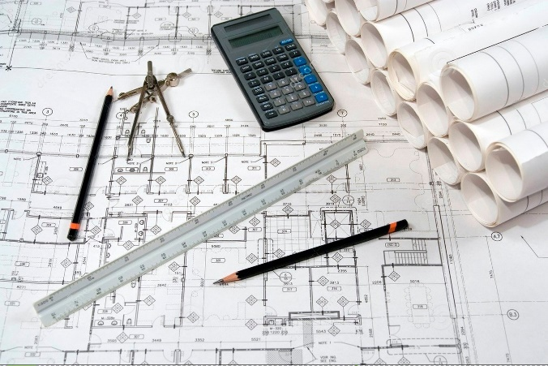**

**MATH APPRECIATION WEEK  
Math Competition 2025**

Wed, April 16, 12:15 – 1:45pm in KC-101

Skills up to MATH 067 required (Algebra/Geometry): Calculators provided!  
Teams arriving after 12:25 may be disqualified. Each team must have 4 currently enrolled student members. Bring your cheering section!

**1st prize for a team of 4 current HCC students is $1000!!**(Other prizes are also awarded)

Team Name:____________________________________

(Forms submitted without a team name will be given one)

Member #1__________________________phone__________________ID#________________

Member #2__________________________phone__________________ID#________________

Member #3__________________________phone__________________ID#________________

Member #4__________________________phone__________________ID#________________  
  
Math instructor(s), if you have any_________________________________________________

**Please return form to KC-300 or register via QR code by 4/14. First come, first serve!**